

|  |
| --- |
| IPcollector |
| Setup Reference |
|  |

|  |
| --- |
| This document contains material that is the proprietary property of IPsoft. Disclosure outside IPsoft is prohibited except by licensed or other confidentiality agreement.  Copyright © 2015 IPsoft Inc. All rights reserved. |

Contents

IPcollector Setup 3

1 Obtaining the IPmon image files 3

1.1 OVA files 3

2 Installing the OVA image file 3

3 Initial Console/Server setup 6

3.1 Connect to the IPcollector console 6

4 Configure OVPN Tunnel for IPcollector 6

5 IPcollector Install 12

6 Adding IPcollector to IPcenter UI 12

Document History

|  |  |  |  |  |
| --- | --- | --- | --- | --- |
| **Author** | **Version** | **Date** | **Comments** | **Final Approval?** |
| Chris Baugus | .1 | 6/2/15 | Initial version | yes |
| Dalia Landes | .2 | 6/2/15 | formatted | yes |
| Charlie Chang | .3 | 6/10/15 | Updated FTP/OVA info | no |
| Kristen McFadden | 1.0 | 6/10/15 | Final approver | Yes |
| William Pak | 1.1 | 7/14/15 | Updated content and format |  |

IPcollector Setup

# Obtaining the IPmon image files

All files can be found on:

[**sftp://ftp01.ny1.ipsoft.com**](ftp://ftp01.ny1.ipsoft.com:/ftpdata/ipmonova/IPmon)

**Username: ibmipcenterdeploy**

**Password:** t2Amazetud

## OVA files

Please use the following OVA to deploy IPcollector/IPmon/IPjump:

**IPsoft-RHEL-6.6-vAPP-05092015.ova**

# Installing the OVA image file

Once the VM has been created, you can start the install of the OVA.

NOTE: VM specifications are currently:

Once logged into vCenter, select “Deploy OVF Template” :

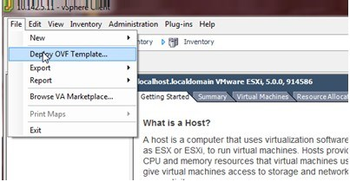

Using the Browse button, select the OVA file that you downloaded.

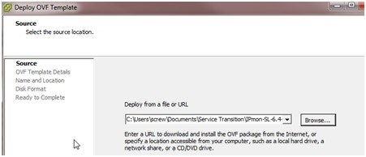

Begin the installation process (on many of these screens it is simply the Default),

On the initial screen it will ask you to provide a **Name** for the IPmon.

It will then prompt for the following information:

**Domain**

**Gateway**

**Hostname**

**IPcenter Instance**

**IP**

**Netmask**

**OVPN: “Local” #Unless otherwise directed**

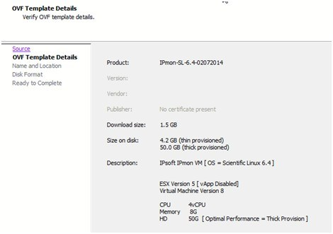

Select “Next.” Enter the Name for the new IPmon (i.e. ipmon{xx}.{Clientcode}.

Select “Next” :

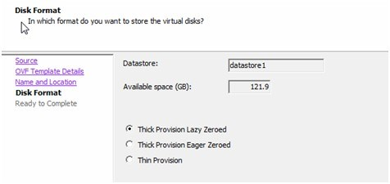

Select “Next” :

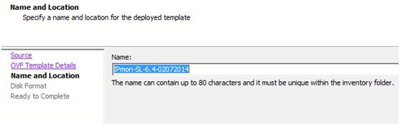

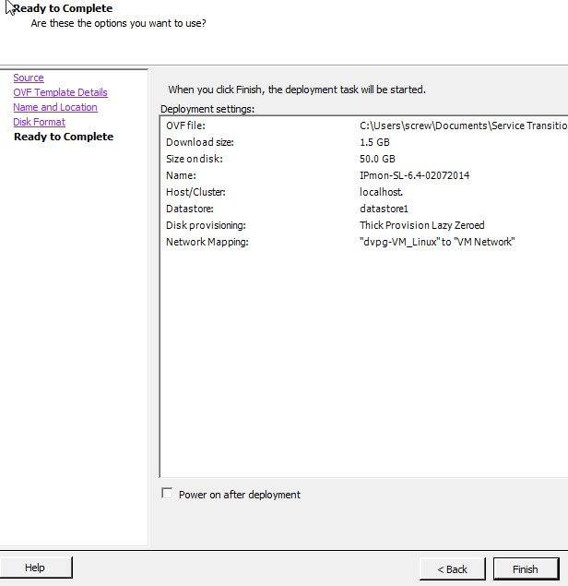

Then select “ Finish” to start the OVA install.

**Once the OVA install has completed, you can start with building the iPmon.**

Initial Console/Network Configuration

# Initial Console/Server setup

Initial setup on the Ipcollector

Log into the IPcollector and run:

/root/server_setup.sh

*The setup script will ask the required questions to setup the server*

HOSTNAME = ipcollector01.prod #The Hostname of the server

IP=10.0.0.1 #IP address of the server

NETMASK=255.255.255.0 #Network mask of the server

GATEWAY=10.0.0.1 #Gateway address of the server

PURPOSE = IPcollector

ENGINE=None

DOMAIN="ibmna.ipsoft.com" #Setup the ipmon domain name

OVPN="Server" #

INSTANCE= # the center URL

**Server reboots and is ready for OVPN setup**

# Configure OVPN Tunnel for IPcollector

There are several steps involved in setting up the OVPN.  
Create a host specific configuration on the OVPN server.

1. Log into the openvpn server
   1. # /etc/openvpn/addconnection.sh <hostname>

/etc/openvpn/addconnection.sh ipmon01.dev.ibm-sop.ipcenter.com

Generating OpenVPN Client Configuration for ipmon01.dev.ibm-sop.ipcenter.com ...Continue? [Y/n]Y

Default SSL Key bit length is 2048. If higher encryption is desired, enter custom key bit length [2048 --> 8192]:

Default SSL Cert expiry is 10 years, if a different expiry is desired, enter custom expiry time [2 --> 10]:

OpenVPN Client Configuration for ipmon01.dev.ibm-sop.ipcenter.com

------------------------------------------------

Generation Date: 2015-07-07 18:54:14 GMT

Adding reverse connection for ipmon01.dev.ibm-sop.ipcenter.com...

Assiging 198.18.121.2 and 198.18.121.1 to tunnel...

NOTE: If you run ./clean-all, I will be doing a rm -rf on /etc/openvpn/easy-rsa/keys

Generating a 2048 bit RSA private key

...........................+++

................................................................................................+++

writing new private key to 'ipmon01.dev.ibm-sop.ipcenter.com.key'

-----

Using configuration from /etc/openvpn/easy-rsa/openssl.cnf

Check that the request matches the signature

Signature ok

The Subject's Distinguished Name is as follows

countryName :PRINTABLE:'US'

stateOrProvinceName :PRINTABLE:'NY'

localityName :PRINTABLE:'New York'

organizationName :PRINTABLE:'IBM'

commonName :PRINTABLE:'ipmon01.dev.ibm-sop.ipcenter.com'

Certificate is to be certified until Jul 4 18:54:55 2025 GMT (3650 days)

Write out database with 1 new entries

Data Base Updated

* 1. # rsync -av remoteconfigs/<hostname>/* <hostname>:/etc/openvpn  
     (If you don't have root access, copy it to a different location and then move it to the /etc/openvpn)

cd /etc/openvpn/

rsync -av remoteconfigs/<hostname>/* <hostname>:/etc/openvpn

Example:

rsync -av remoteconfigs/ipmon01.dev.ibm-sop.ipcenter.com/* ipmon01.dev.ibm-sop.ipcenter.com:/etc/openvpn

The authenticity of host 'ipmon01.dev.ibm-sop.ipcenter.com (10.140.231.15)' can't be established.

RSA key fingerprint is e7:d4:2d:af:ed:72:24:99:93:db:5a:1d:e0:b8:95:00.

Are you sure you want to continue connecting (yes/no)? yes

Warning: Permanently added 'ipmon01.dev.ibm-sop.ipcenter.com,10.140.231.15' (RSA) to the list of known hosts.

root@ipmon01.dev.ibm-sop.ipcenter.com's password:

sending incremental file list

ipmon01.dev.ibm-sop.ipcenter.com.conf

pki/

pki/ca.crt

pki/ipmon01.dev.ibm-sop.ipcenter.com.crt

pki/ipmon01.dev.ibm-sop.ipcenter.com.key

sent 8805 bytes received 92 bytes 480.92 bytes/sec

total size is 8472 speedup is 0.95

1. Log onto the IPmon
   1. Start openvpn process on IPcollector

/etc/init.d/openvpn start

1. Verify connection vpn tunnel between IPcollector and VPN host

**On the OVPN server:**

cd /var/log/openvpn/

ls -ltra

Example output:

total 68

-rw-------.  1 root root    0 Jun 24 21:14 keepalived.log

-rw-------.  1 root root    0 Jun 24 21:14 injectrouted.log

-rw-------.  1 root root  922 Jun 28 03:42 [ovpn01.dev.ibm-sop.ipcenter.com](http://ovpn01.dev.ibm-sop.ipcenter.com/)-443.log-20150628.gz

-rw-------.  1 root root  194 Jun 28 03:42 [ovpn01.dev.ibm-sop.ipcenter.com](http://ovpn01.dev.ibm-sop.ipcenter.com/)-443_status.log-20150628.gz

-rw-------.  1 root root  194 Jun 28 03:42 [ovpn01.dev.ibm-sop.ipcenter.com](http://ovpn01.dev.ibm-sop.ipcenter.com/)-80_status.log-20150628.gz

-rw-------.  1 root root  877 Jun 28 03:42 [ovpn01.dev.ibm-sop.ipcenter.com](http://ovpn01.dev.ibm-sop.ipcenter.com/)-80.log-20150628.gz

-rw-------.  1 root root  175 Jun 28 03:42 $OVPN_FQDN-80.log-20150628.gz

-rw-------.  1 root root    0 Jun 28 03:42 $OVPN_FQDN-80.log

-rw-------.  1 root root  875 Jul  5 03:36 [ovpn01.dev.ibm-sop.ipcenter.com](http://ovpn01.dev.ibm-sop.ipcenter.com/)-443.log-20150705.gz

-rw-------.  1 root root  981 Jul  5 03:36 [ovpn01.dev.ibm-sop.ipcenter.com](http://ovpn01.dev.ibm-sop.ipcenter.com/)-80.log-20150705.gz

-rw-------.  1 root root  192 Jul  5 03:36 [ovpn01.dev.ibm-sop.ipcenter.com](http://ovpn01.dev.ibm-sop.ipcenter.com/)-443_status.log-20150705.gz

-rw-------.  1 root root  192 Jul  5 03:36 [ovpn01.dev.ibm-sop.ipcenter.com](http://ovpn01.dev.ibm-sop.ipcenter.com/)-80_status.log-20150705.gz

drwxr-xr-x. 15 root root 4096 Jul  5 03:36 ..

drwxr-xr-x.  2 root root 4096 Jul  7 18:54 .

-rw-r--r--.  1 root root 1130 Jul  7 18:54 client_config.log

-rw-------.  1 root root 2370 Jul  7 19:04 [ovpn01.dev.ibm-sop.ipcenter.com](http://ovpn01.dev.ibm-sop.ipcenter.com/)-80.log

-rw-------.  1 root root 6864 Jul  7 19:25 [ovpn01.dev.ibm-sop.ipcenter.com](http://ovpn01.dev.ibm-sop.ipcenter.com/)-443.log

-rw-------.  1 root root  412 Jul  7 19:34 [ovpn01.dev.ibm-sop.ipcenter.com](http://ovpn01.dev.ibm-sop.ipcenter.com/)-443_status.log

-rw-------.  1 root root  232 Jul  7 19:35 [ovpn01.dev.ibm-sop.ipcenter.com](http://ovpn01.dev.ibm-sop.ipcenter.com/)-80_status.log

grep -i ipmon *.log

Example output:

client_config.log: OpenVPN Client Configuration for [ipmon01.dev.ibm-sop.ipcenter.com](http://ipmon01.dev.ibm-sop.ipcenter.com/)

client_config.log:Adding reverse connection for [ipmon01.dev.ibm-sop.ipcenter.com](http://ipmon01.dev.ibm-sop.ipcenter.com/)...

client_config.log:writing new private key to 'ipmon01.dev.ibm-sop.ipcenter.com.key'

client_config.log:commonName            :PRINTABLE:'[ipmon01.dev.ibm-sop.ipcenter.com](http://ipmon01.dev.ibm-sop.ipcenter.com/)'

[ovpn01.dev.ibm-sop.ipcenter.com](http://ovpn01.dev.ibm-sop.ipcenter.com/)-443.log:Tue Jul  7 19:04:38 2015 10.140.231.15:51416 VERIFY OK: depth=0, C=US, ST=NY, L=New York, O=IBM, CN=[ipmon01.dev.ibm-sop.ipcenter.com](http://ipmon01.dev.ibm-sop.ipcenter.com/)

[ovpn01.dev.ibm-sop.ipcenter.com](http://ovpn01.dev.ibm-sop.ipcenter.com/)-443.log:Tue Jul  7 19:04:38 2015 10.140.231.15:51416 [[ipmon01.dev.ibm-sop.ipcenter.com](http://ipmon01.dev.ibm-sop.ipcenter.com/)] Peer Connection Initiated with [AF_INET]10.140.231.15:51416

[ovpn01.dev.ibm-sop.ipcenter.com](http://ovpn01.dev.ibm-sop.ipcenter.com/)-443.log:Tue Jul  7 19:04:38 2015 [ipmon01.dev.ibm-sop.ipcenter.com/10.140.231.15:51416](http://ipmon01.dev.ibm-sop.ipcenter.com/10.140.231.15:51416) OPTIONS IMPORT: reading client specific options from: ccd/[ipmon01.dev.ibm-sop.ipcenter.com](http://ipmon01.dev.ibm-sop.ipcenter.com/)

[ovpn01.dev.ibm-sop.ipcenter.com](http://ovpn01.dev.ibm-sop.ipcenter.com/)-443.log:Tue Jul  7 19:04:38 2015 [ipmon01.dev.ibm-sop.ipcenter.com/10.140.231.15:51416](http://ipmon01.dev.ibm-sop.ipcenter.com/10.140.231.15:51416) MULTI: Learn: 198.18.121.2 -> [ipmon01.dev.ibm-sop.ipcenter.com/10.140.231.15:51416](http://ipmon01.dev.ibm-sop.ipcenter.com/10.140.231.15:51416)

[ovpn01.dev.ibm-sop.ipcenter.com](http://ovpn01.dev.ibm-sop.ipcenter.com/)-443.log:Tue Jul  7 19:04:38 2015 [ipmon01.dev.ibm-sop.ipcenter.com/10.140.231.15:51416](http://ipmon01.dev.ibm-sop.ipcenter.com/10.140.231.15:51416) MULTI: primary virtual IP for [ipmon01.dev.ibm-sop.ipcenter.com/10.140.231.15:51416:](http://ipmon01.dev.ibm-sop.ipcenter.com/10.140.231.15:51416:) 198.18.121.2

[ovpn01.dev.ibm-sop.ipcenter.com](http://ovpn01.dev.ibm-sop.ipcenter.com/)-443.log:Tue Jul  7 19:04:40 2015 [ipmon01.dev.ibm-sop.ipcenter.com/10.140.231.15:51416](http://ipmon01.dev.ibm-sop.ipcenter.com/10.140.231.15:51416) PUSH: Received control message: 'PUSH_REQUEST'

[ovpn01.dev.ibm-sop.ipcenter.com](http://ovpn01.dev.ibm-sop.ipcenter.com/)-443.log:Tue Jul  7 19:04:40 2015 [ipmon01.dev.ibm-sop.ipcenter.com/10.140.231.15:51416](http://ipmon01.dev.ibm-sop.ipcenter.com/10.140.231.15:51416) send_push_reply(): safe_cap=940

[ovpn01.dev.ibm-sop.ipcenter.com](http://ovpn01.dev.ibm-sop.ipcenter.com/)-443.log:Tue Jul  7 19:04:40 2015 [ipmon01.dev.ibm-sop.ipcenter.com/10.140.231.15:51416](http://ipmon01.dev.ibm-sop.ipcenter.com/10.140.231.15:51416) SENT CONTROL [[ipmon01.dev.ibm-sop.ipcenter.com](http://ipmon01.dev.ibm-sop.ipcenter.com/)]: 'PUSH_REPLY,route 198.18.121.1,topology net30,ping 14,ping-restart 120,route 198.18.254.0 255.255.254.0,ifconfig 198.18.121.2 198.18.121.1' (status=1)

[ovpn01.dev.ibm-sop.ipcenter.com](http://ovpn01.dev.ibm-sop.ipcenter.com/)-443.log:Tue Jul  7 19:25:32 2015 [ipmon01.dev.ibm-sop.ipcenter.com/10.140.231.15:51416](http://ipmon01.dev.ibm-sop.ipcenter.com/10.140.231.15:51416) Connection reset, restarting [0]

[ovpn01.dev.ibm-sop.ipcenter.com](http://ovpn01.dev.ibm-sop.ipcenter.com/)-443.log:Tue Jul  7 19:25:32 2015 [ipmon01.dev.ibm-sop.ipcenter.com/10.140.231.15:51416](http://ipmon01.dev.ibm-sop.ipcenter.com/10.140.231.15:51416) SIGUSR1[soft,connection-reset] received, client-instance restarting

[ovpn01.dev.ibm-sop.ipcenter.com](http://ovpn01.dev.ibm-sop.ipcenter.com/)-443.log:Tue Jul  7 19:25:37 2015 10.140.231.15:51510 VERIFY OK: depth=0, C=US, ST=NY, L=New York, O=IBM, CN=[ipmon01.dev.ibm-sop.ipcenter.com](http://ipmon01.dev.ibm-sop.ipcenter.com/)

[ovpn01.dev.ibm-sop.ipcenter.com](http://ovpn01.dev.ibm-sop.ipcenter.com/)-443.log:Tue Jul  7 19:25:38 2015 10.140.231.15:51510 [[ipmon01.dev.ibm-sop.ipcenter.com](http://ipmon01.dev.ibm-sop.ipcenter.com/)] Peer Connection Initiated with [AF_INET]10.140.231.15:51510

[ovpn01.dev.ibm-sop.ipcenter.com](http://ovpn01.dev.ibm-sop.ipcenter.com/)-443.log:Tue Jul  7 19:25:38 2015 [ipmon01.dev.ibm-sop.ipcenter.com/10.140.231.15:51510](http://ipmon01.dev.ibm-sop.ipcenter.com/10.140.231.15:51510) OPTIONS IMPORT: reading client specific options from: ccd/[ipmon01.dev.ibm-sop.ipcenter.com](http://ipmon01.dev.ibm-sop.ipcenter.com/)

[ovpn01.dev.ibm-sop.ipcenter.com](http://ovpn01.dev.ibm-sop.ipcenter.com/)-443.log:Tue Jul  7 19:25:38 2015 [ipmon01.dev.ibm-sop.ipcenter.com/10.140.231.15:51510](http://ipmon01.dev.ibm-sop.ipcenter.com/10.140.231.15:51510) MULTI: Learn: 198.18.121.2 -> [ipmon01.dev.ibm-sop.ipcenter.com/10.140.231.15:51510](http://ipmon01.dev.ibm-sop.ipcenter.com/10.140.231.15:51510)

[ovpn01.dev.ibm-sop.ipcenter.com](http://ovpn01.dev.ibm-sop.ipcenter.com/)-443.log:Tue Jul  7 19:25:38 2015 [ipmon01.dev.ibm-sop.ipcenter.com/10.140.231.15:51510](http://ipmon01.dev.ibm-sop.ipcenter.com/10.140.231.15:51510) MULTI: primary virtual IP for [ipmon01.dev.ibm-sop.ipcenter.com/10.140.231.15:51510:](http://ipmon01.dev.ibm-sop.ipcenter.com/10.140.231.15:51510:) 198.18.121.2

[ovpn01.dev.ibm-sop.ipcenter.com](http://ovpn01.dev.ibm-sop.ipcenter.com/)-443.log:Tue Jul  7 19:25:40 2015 [ipmon01.dev.ibm-sop.ipcenter.com/10.140.231.15:51510](http://ipmon01.dev.ibm-sop.ipcenter.com/10.140.231.15:51510) PUSH: Received control message: 'PUSH_REQUEST'

[ovpn01.dev.ibm-sop.ipcenter.com](http://ovpn01.dev.ibm-sop.ipcenter.com/)-443.log:Tue Jul  7 19:25:40 2015 [ipmon01.dev.ibm-sop.ipcenter.com/10.140.231.15:51510](http://ipmon01.dev.ibm-sop.ipcenter.com/10.140.231.15:51510) send_push_reply(): safe_cap=940

[ovpn01.dev.ibm-sop.ipcenter.com](http://ovpn01.dev.ibm-sop.ipcenter.com/)-443.log:Tue Jul  7 19:25:40 2015 [ipmon01.dev.ibm-sop.ipcenter.com/10.140.231.15:51510](http://ipmon01.dev.ibm-sop.ipcenter.com/10.140.231.15:51510) SENT CONTROL [[ipmon01.dev.ibm-sop.ipcenter.com](http://ipmon01.dev.ibm-sop.ipcenter.com/)]: 'PUSH_REPLY,route 198.18.121.1,topology net30,ping 14,ping-restart 120,route 198.18.254.0 255.255.254.0,ifconfig 198.18.121.2 198.18.121.1' (status=1)

[ovpn01.dev.ibm-sop.ipcenter.com](http://ovpn01.dev.ibm-sop.ipcenter.com/)-443_status.log:ipmon01.[dev.ibm-sop.ipcenter.com](http://dev.ibm-sop.ipcenter.com/),10.140.231.15:51510,12480,7774,Tue Jul  7 19:25:36 2015

[ovpn01.dev.ibm-sop.ipcenter.com](http://ovpn01.dev.ibm-sop.ipcenter.com/)-443_status.log:198.18.121.2,[ipmon01.dev.ibm-sop.ipcenter.com](http://ipmon01.dev.ibm-sop.ipcenter.com/),10.140.231.15:51510,Tue Jul  7 19:32:33 2015

lsof|grep ipcollector

Example output:

openvpn   23931      root    8u     IPv4            1893461      0t0        TCP ovpn01.dev.ibm-sop.ipcenter.com:https->[ipmon01.dev.ibm-sop.ipcenter.com](http://ipmon01.dev.ibm-sop.ipcenter.com/):51510 (ESTABLISHED)

**On IPcollector:**

Start openvpn:

/etc/init.d/openvpn start

Starting openvpn:                                          [  OK  ]

Check that the tun0 device was created:

ifconfig tun0

tun0      Link encap:UNSPEC  HWaddr 00-00-00-00-00-00-00-00-00-00-00-00-00-00-00-00

          inet addr:198.18.121.2  P-t-P:198.18.121.1  Mask:255.255.255.255

          UP POINTOPOINT RUNNING NOARP MULTICAST  MTU:1500  Metric:1

          RX packets:0 errors:0 dropped:0 overruns:0 frame:0

          TX packets:0 errors:0 dropped:0 overruns:0 carrier:0

          collisions:0 txqueuelen:100

          RX bytes:0 (0.0 b)  TX bytes:0 (0.0 b)

Ping the P-t-P IP to test connectivity to the OVPN server.

ping 198.18.121.1

# IPcollector Install

1. Verify IPcollector installed and update with yum if not at 1.9.9 or newer

rpm -qa | grep IPcollector

yum update IPcollector

1. Reload httpd service

/etc/init.d/httpd reload

1. Customize Configuration

cp /apps/IPsoft/IPcollector/etc/defaults_ipcollector.properties /apps/IPsoft/IPcollector/etc/ipcollector.properties

sed --in-place 's/clientcode-IPmon/%clientcode%-IPmon/' /apps/IPsoft/IPcollector/etc/ipcollector.properties # edit %clientcode%

sed --in-place 's/dialect.external_event.enabled=false/dialect.external_event.enabled=true/' /apps/IPsoft/IPcollector/etc/ipcollector.properties

1. Setup database

echo 'create database IPcollector' | mysql -u root -p

echo "grant all on IPcollector.* to 'IPcollector'@'localhost' identified by '1pc0ll3ct0r'" | mysql -u root –p

mysql -u root IPcollector -p < /apps/IPsoft/IPcollector/etc/tables_mysql_innodb.sql

1. Start IPcollector

/etc/init.d/IPcollector start

tail -f /apps/IPsoft/IPcollector/logs/console.log #look for errors

# Adding IPcollector to IPcenter UI

The IPcollector needs to be associated with the IPcenter instance

**Prerequisite**

A fully deployed and functioning IPcenter

**Directions**

1. Log into the IPcenter with an administrator account
2. Navigate to Service Transition -> IPdeploy
3. Click on the appropriate client name
4. Click on ‘IPmon’ in the ‘Appplication Configuration’ section
5. Click ‘Edit Services’
6. Click ‘Add new Service’
7. Fill in the fields that appear
   1. Service: Choose a name for the IPcollector. This is usually derived from the hostname ie $CLIENT-PROD-IPcollector1
   2. Protocol: http://
   3. Address: Enter the FQDN of the IPcollector
   4. Port: 80
   5. Path: /IPcollector
   6. Description: Enter a brief description of the IPmon (For human reference)
   7. IPremote Port: 1023
   8. Active: Check the box
8. Click ‘Update’ to save
9. Check that the IPcollector was successfully added
   1. Navigate to Service Operation -> IPradar
   2. Expand the ‘--- IPmons ---’ dropdown menu, choose the added IPcollector, and click ‘Go’  
      
   3. You should be redirected to the status page of the IPcollector
   4. If not, review the fields in IPdeploy added in step 7 and ensure httpd and the IPcollector service is running on the IPcollector
10. Create the IPmon Host Classifier for this IPcollector in IPclassify
    1. Navigate to Service Technology -> IPclassify
    2. On the ‘IPmon Host Classifier’ line, click ‘Edit Rules’
    3. Find the section for the newly added IPcollector (the name is pulled from the Service field from step 7a)
    4. Click ‘Add Rule’
    5. Under ‘Regular Expression’ enter the FQDN of the IPcollector
    6. Under ‘Message Part Selector’ select ‘Message-Id’
    7. Click ‘Save Changes’